Sample Concentrator—ND300-1
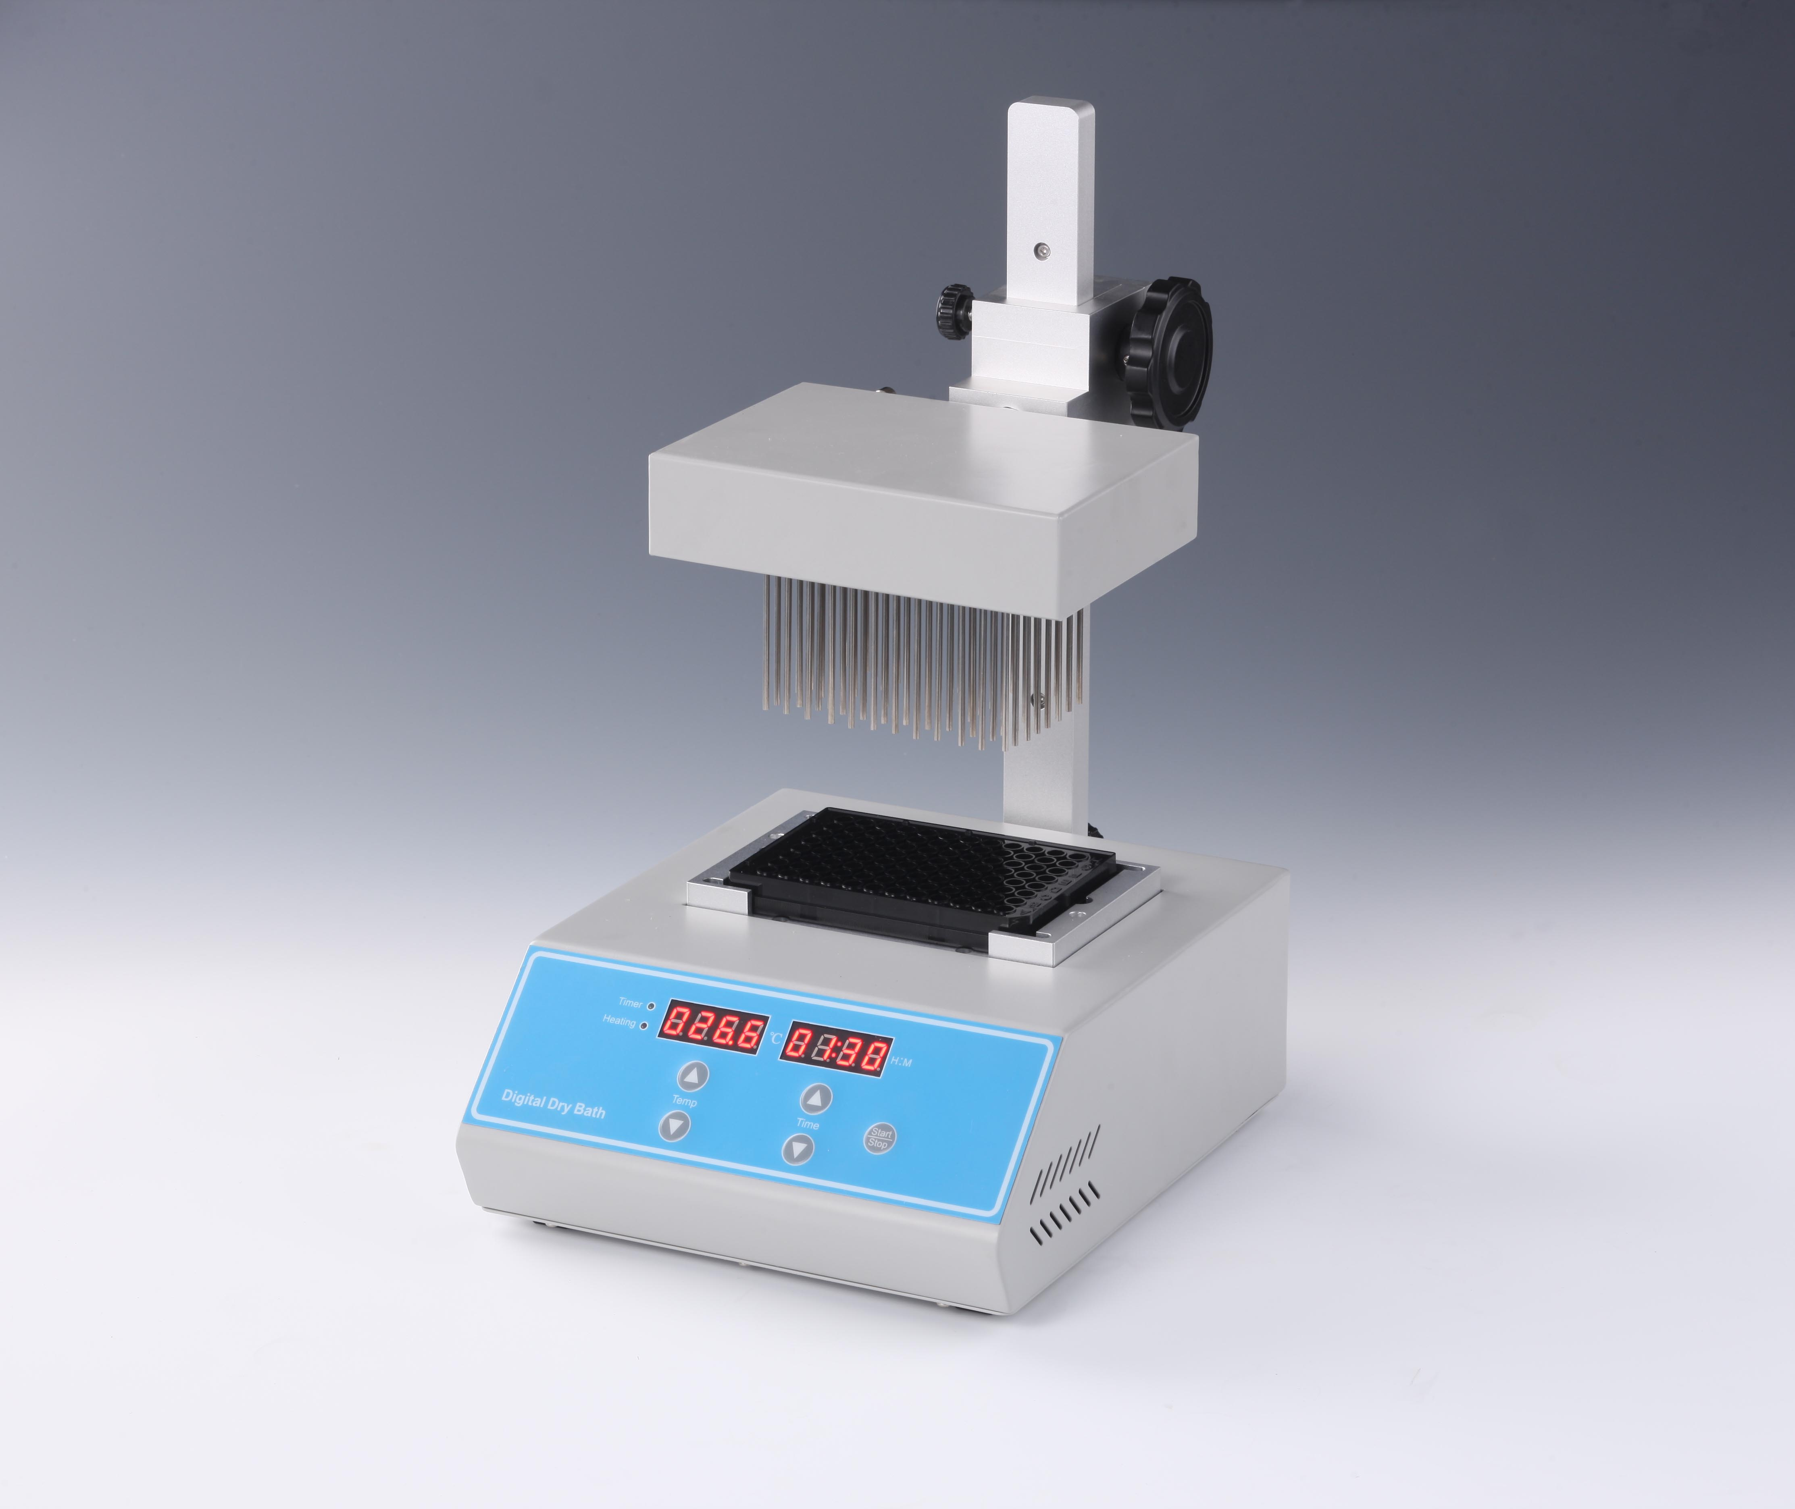
Description:
Sample concentrator is a high precision temperature control instrument with microprocessor controlled and PID fuzzy controlled technique. It works by blowing nitrogen in the surface of sample which is being heated to accelerate evaporating and separating the solvent in the samples without oxygen. Instead of rotary evaporation instrument, nitrogen sample concentrator can efficiently concentrate a large of samples simultaneously.

Features:
◆ High precision and wide range of temp control.
◆ Blowing a large number of samples at one time.
◆ Blowing each sample independently.
◆ Easy operation; safe and reliable to use.

Application fields
- Analysis of pesticide residues: vegetables, fruits, cereals, plant tissue.
- Environmental analysis: such as drinking water, groundwater and polluted water samples.
- Biological analysis: such as hormone analysis, sample preparation of liquid phase and gas phase and mass spectrometry analysis.
- Food and beverage: such as milk, wine, beer, etc.
- Pharmaceutical drug testing: such as traditional Chinese medicine pharmaceutical, drug screening.

Parameters:
Model | ND300-1
Temp range | RT.+5°C -160°C
Temp accuracy | ±0.5°C(@40°C)
Temp accuracy | ±1°C(@120°C)
Temp uniformity | ±0.5°C
Display accuracy | 0.1°C
Time Range | 1-99h59min/∞
Heating time | ≤15min(25°C to 160°C)
Max vertical travel | 150mm
Max gas usage | 15L/min
Max gas pressure | 0.05Mpa
Block qty | 1
Max power | 500W
Voltage | 220V or 110V 50/60Hz
Dimension(mm) | 220x310x385
Weight(kg) | 7.5

Blocks
Type | Test tube diameter | Capacity | Dimension(mm)
MD17 | 0.2ml PCR plate | 96 | 153X95.5X60
MD18 | Elisa plate | 96 | 153X95.5X60

